**Import table into eclipse**

(Note: You can create the tables in lnd3 and import data from lnd3 server to ls4)

Here we can assume that lnd3 is like a non-Hana system)

1) create table in se11

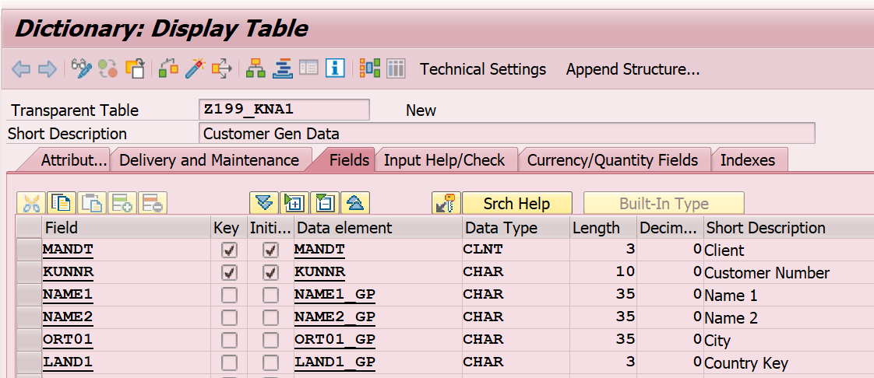

Fill it with below entries through TMG.

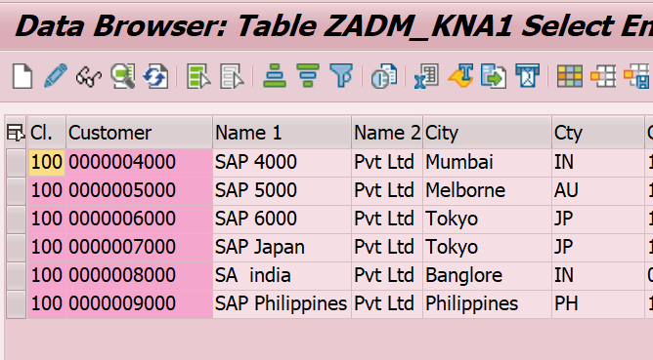

Content - Spreadsheet

1. HERE EXCEL EXTENSION SHOULD XLS

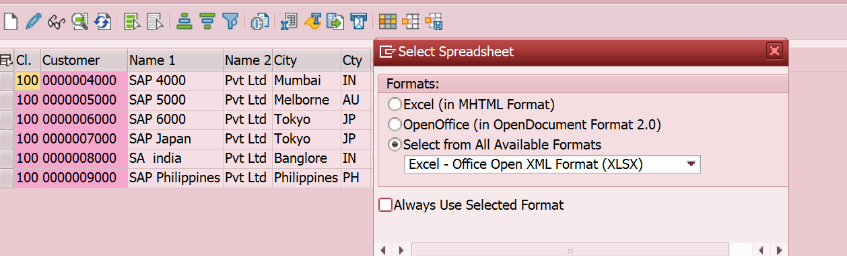





1. To import from eclipse

Modeler perspective.

eclipse -> file -> import -> sap Hana content -> data from local file

-> TRAINEE10 -> browse-path -> header row exists check

-> schematrainee04 -> tablename MT_KNA1 -> keys -> remove client MANDT field -> datatyps changes -> save

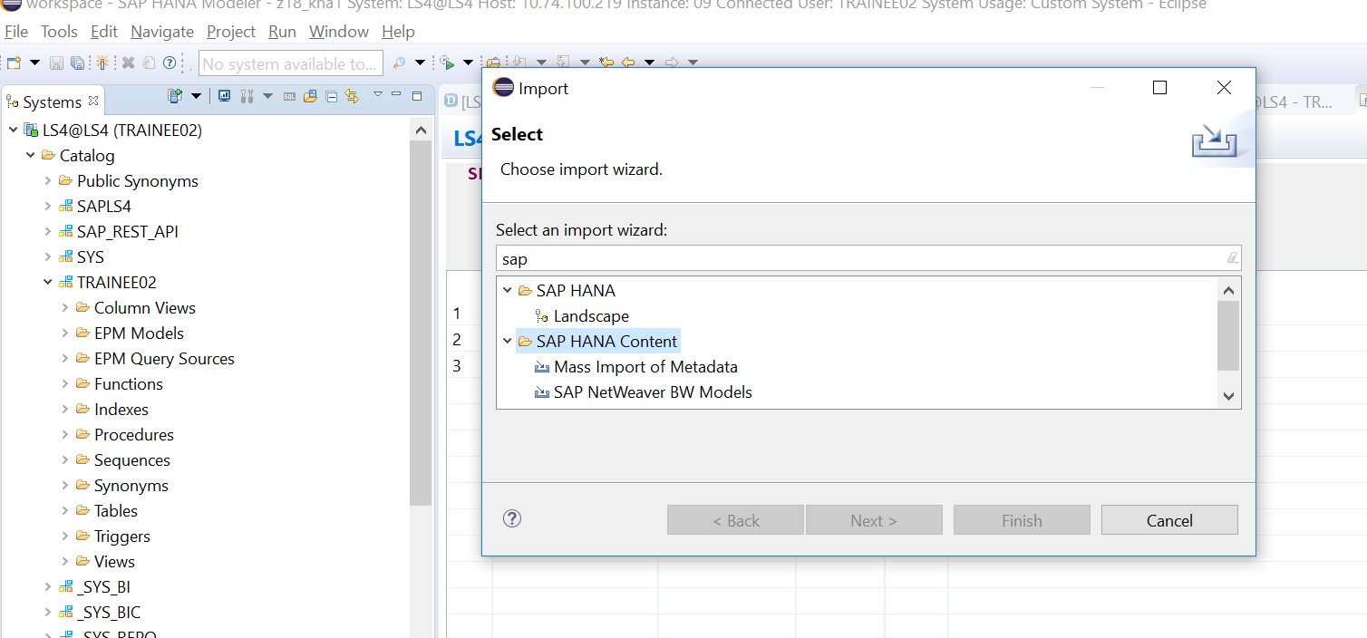

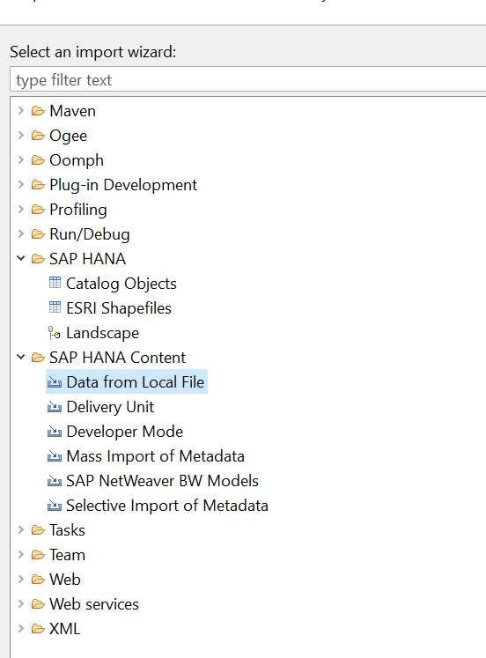

Map the fields. Remove client field.

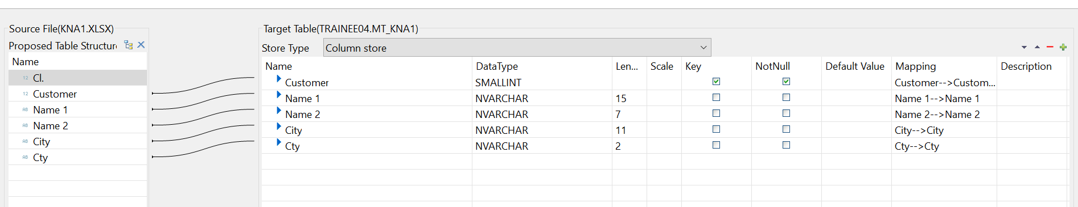

1. Check table in created
2. 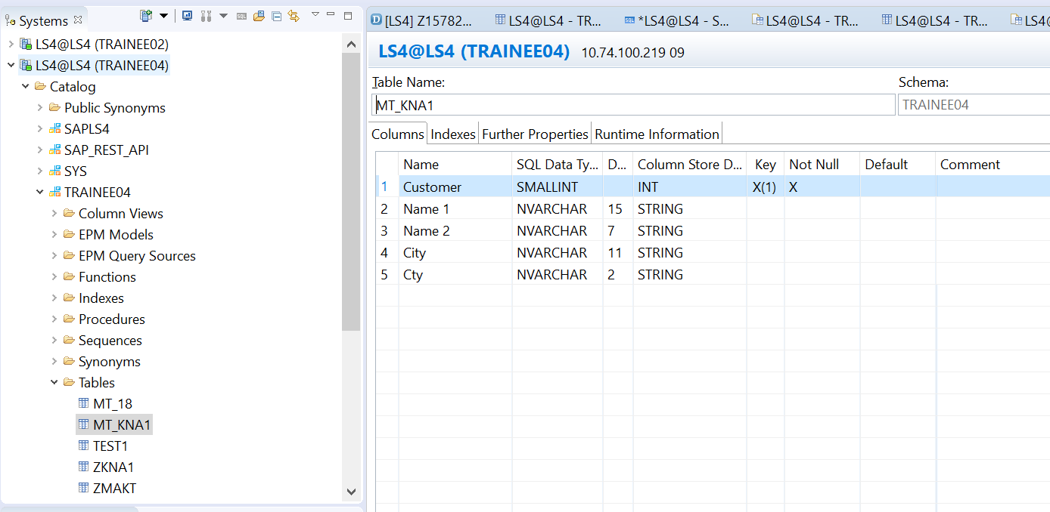
3. Write a select * query and fetch data from the table created.

**select** * **from** TRAINEE10.MT_KNA1

